

User Manual

Virtual Landline Service Orders

For BSNL

User Manual, August,2017

Version 1

TCS Internal, Gurgaon, India

Authors
Vaibhav Sharma

Tata Consultancy Services

Notice
This document contains information that is proprietary and confidential to Tata Consultancy Services, which shall not be disclosed outside Tata Consultancy Services, transmitted, or duplicated, used in whole or in part for any purpose other than its intended purpose. Any use or disclosure in whole or in part of this information without express written permission of Tata Consultancy Services is prohibited. Any other company and product names mentioned are used for identification purposes only, and may be trademarks of their respective owners.

Copyright: TCS 2013

Document Release Note

Customer: B S N L
Project: BSNL CDR2 Rollout Telecom
Document details
Name | Version no. | Description
User Manual for Virtual Landline Service orders | Version 1.0 | Initial Version (original)

Revision details
Action taken  (add/del/change) | Previous  page no. | New page no. | Revision description

The documents or revised pages are subject to document control.
Please keep them up-to-date using the release notices from the distributor of the document.
These are confidential documents. Unauthorized access or copying is prohibited.

Reviewed by:
Date:

Document Revision List

Customer: B S N L
Project: BSNL CDR2 Roll out Telecom
Document Name: User Manual for Virtual Landline Service Orders
Release Notice Reference (for release)

Rev. No. | Revision date | Revision description | Page no. | Previous page no. | Action taken | Addenda/New page | Release notice reference

About this Manual
Introduction
This User Manual has been developed to facilitate the end users with Virtual Landline Service orders implementation.

Table of Contents

Contents
- INTRODUCTION........................................................................................1
- Modify Order for Change of Indicator....................................................2
- Modify Order for Change of Destination Number.......................................8
- Modify Order for Change of Destination Number and Plan.......................14
- Disconnect Order for Virtual Landline ......................................................20
- Complaints..................................................................................................23
- Service Requests for Virtual Landline........................................................25

INTRODUCTION
BSNL plans to introduce the concept of Virtual landline service, in which once the ibase is created the changes can be made accordingly like change of indicator,change of destination number/plan.Further no major changes are with the billing complauints only some subtypes have been removed if the number is for virtual landline.Modifications are there regarding the technical complaints and changes regarding the disconnection has been demonstrated.No such major changes are with the Service requests,functuionality for billiong,account and service are the same.
BSNL primary objective of Virtual Landline Services implementation is to provide:-
- Change of Indicator.
- Change of Destination number/Plan..
- Disconnection of Virtual Landline.
- Changes regarding Service Requests and Complaints.
The services offered by BSNL on which Virtual Landline connections have to be given:
- Landline

Modify Order for Change of Indicator
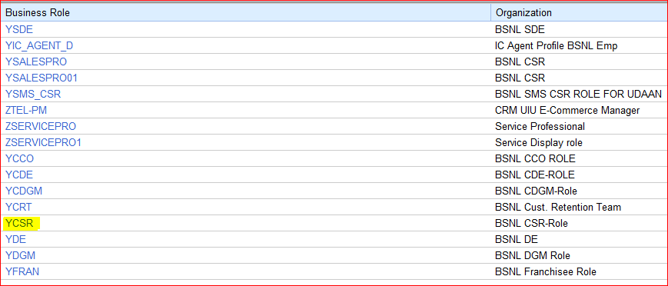
- Login into SAP CRM as CSR.

- Enter the number in Master Data → Customer Assets

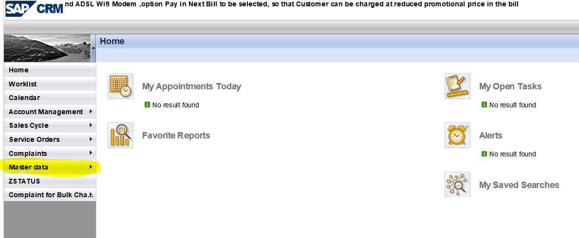

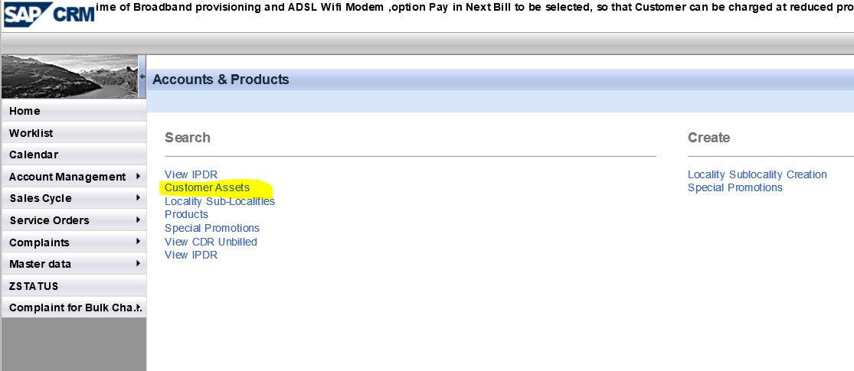

- Enter the Number,IBase will appear with unique asset id.Click on the Asset Id to open the Ibase of that particular number.
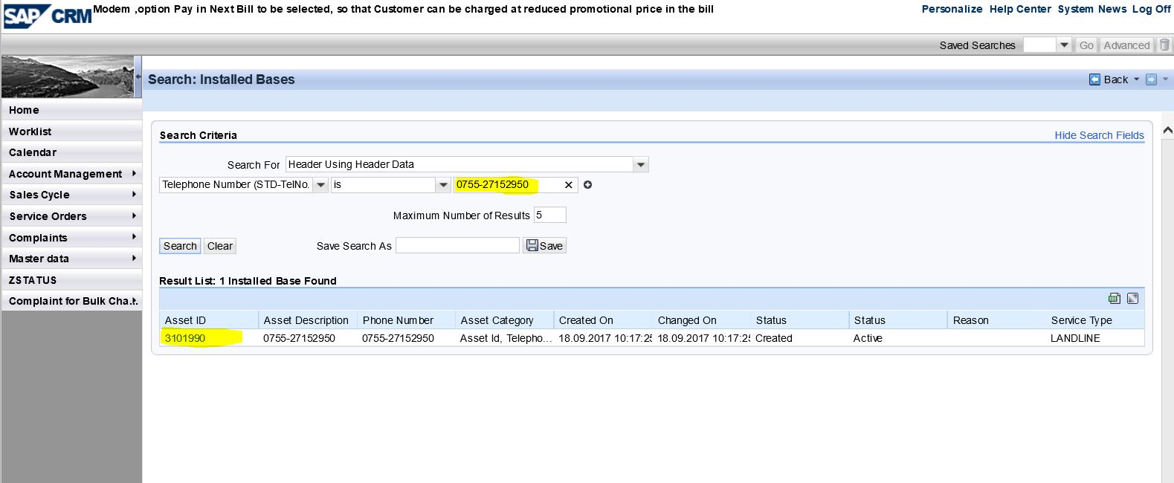

- Note down the Landline Number which is to be changed in the service click on modify and a pop will appear,click on BSNL service order.

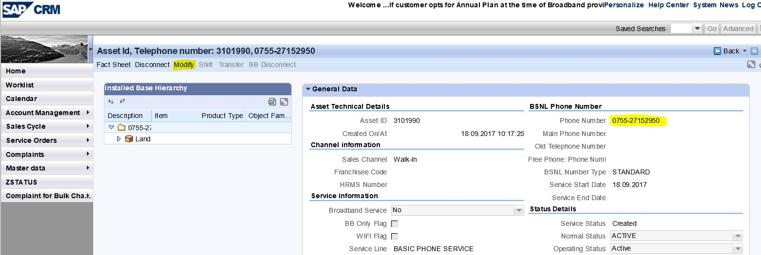

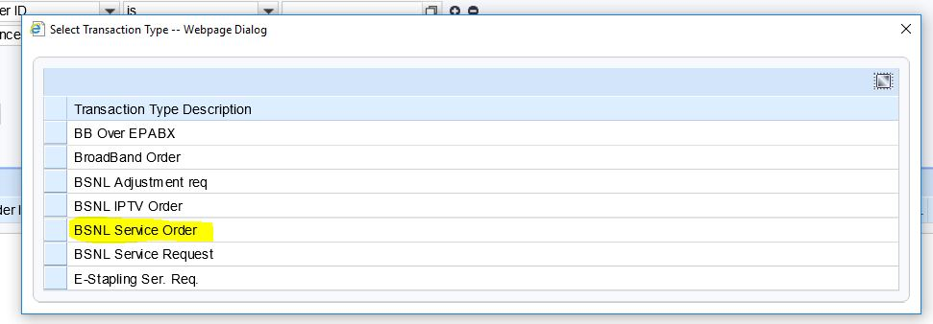

- Service category coloumn will be there with service type,order type and sub order type as follows :

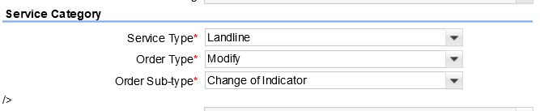
- Click on save and then edit,Number avail check will get enabled.

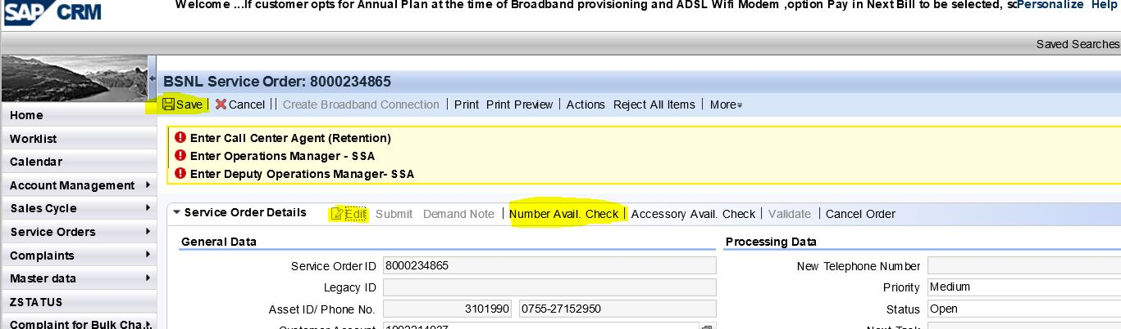

- Choose a new number are reserve it.Click on save submit save to save the order.A new service order id will be created.

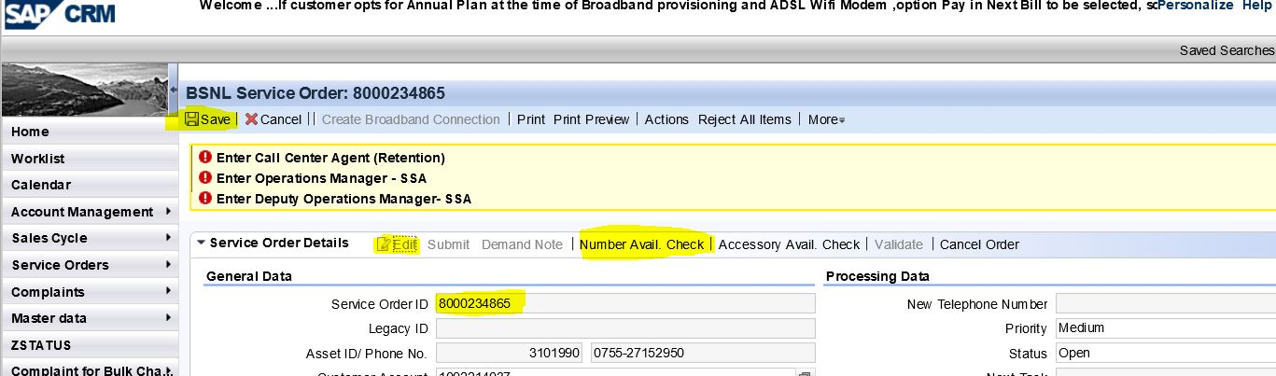
8. The Virtual Landline Service Order has hit Clarity. Clarity will have the following tasks:
a) INDOOR (TASK TYPE: MANUAL)
b) FINAL_TESTING (TASK TYPE: MANUAL)

9. Search in Master data → Customer Assets once the order is completed at clarity with the new number reserved.
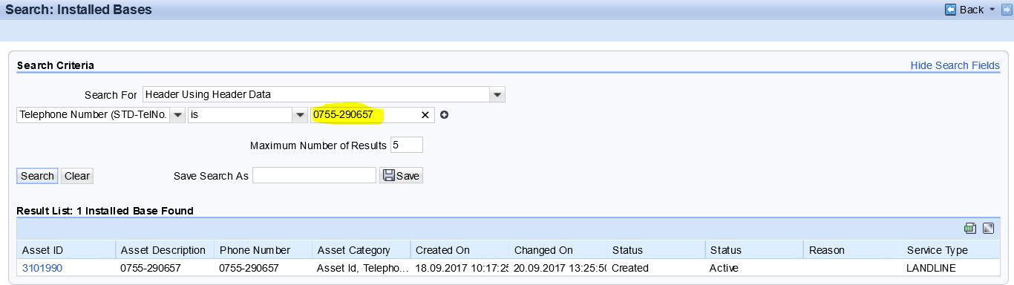

10. When we open the IBASE we can see our new number and the old number as will which has been changed.
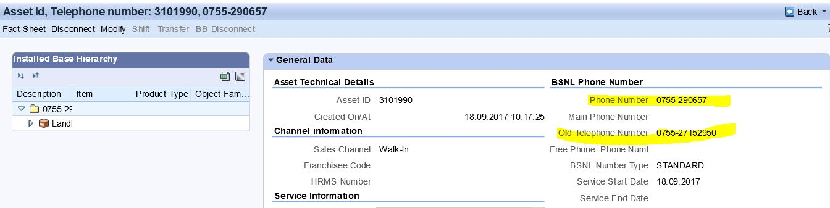

Modify Order for Change of Destination Number
- Login into SAP CRM as CSR.

- Enter the number in Master Data → Customer Assets.
- Enter the Number,IBase will appear with unique asset id.Click on the Asset Id to open the Ibase of that particular number.

- Note down the Destination Number which is to be changed in the service click on modify and a pop will appear,click on BSNL service order.

- Service category coloumn will be there with service type,order type and sub order type as follows :
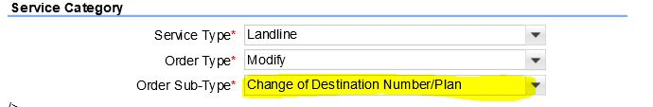

- Click on Open Dashboard Pop will appear with your old destination Number.We have to enter a new number as same destination number cannot be saved again.
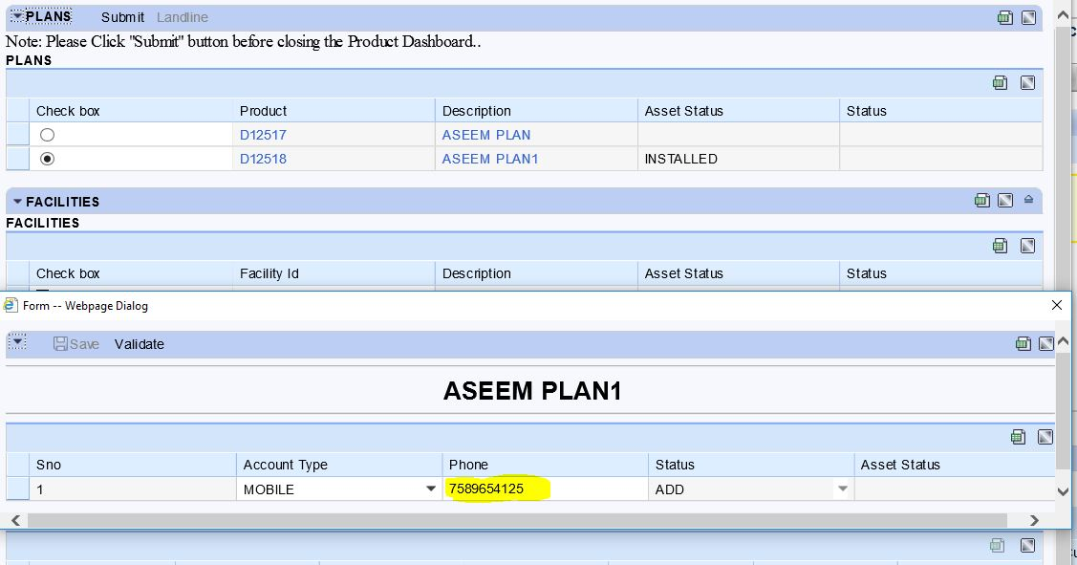
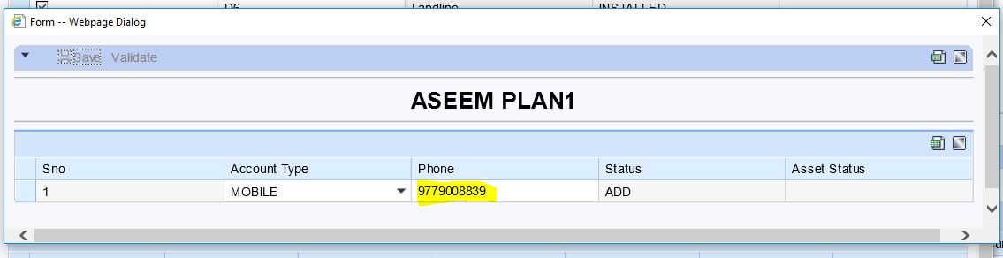

- Destination number will appear on the screen which you have changed.
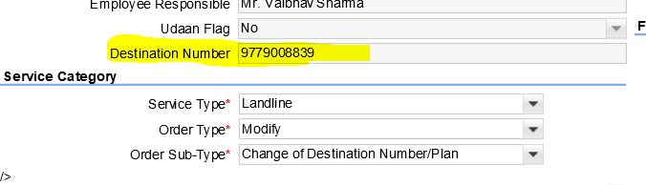
- Click on Save then Submit and again Save button.A new service order id will be generated.

NOTE: Same destination number cannot be selected in the same plan.
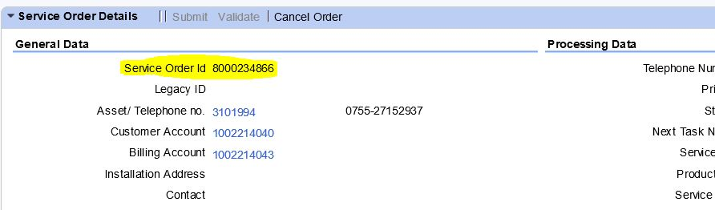

- The Virtual Landline Service Order has hit Clarity. Clarity will have the following tasks:
a) INDOOR (TASK TYPE: MANUAL)

- Search in Master data → Customer Assets once the order is completed at clarity with the new Destination number.

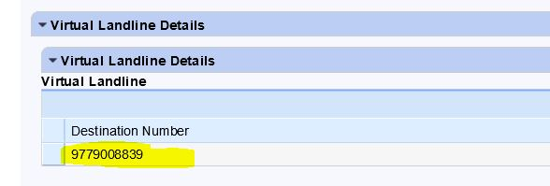

Modify Order for Change of Destination Number and Plan
1. Login into SAP CRM as CSR.

2. Enter the number in Master Data → Customer Assets.
3. Enter the Number,IBase will appear with unique asset id.Click on the Asset Id to open the Ibase of that particular number.

4. Note down the Destination Number which is to be changed in the service click on modify and a pop will appear,click on BSNL service order.

5.Service category coloumn will be there with service type,order type and sub order type as follows :
6.Click on Open Dashboard Pop will appear with your old destination Number and plan.Close the Destination number pop up box and select the new plan and enter the destination number req in new pop up which will appear.
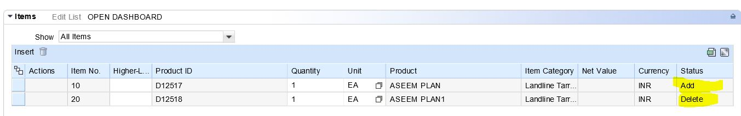
Note : The plan Deleted and new plan which has been installed can be seen.

7. Click on Save,a new service order id will be generated then again click on submit and save.
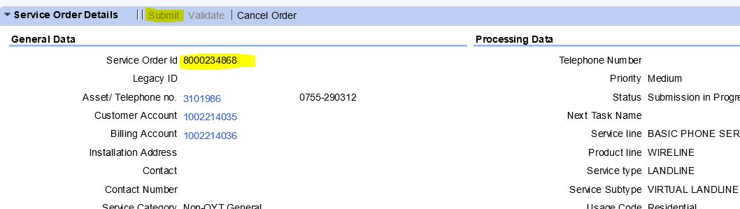
8. The Virtual Landline Service Order has hit Clarity. Clarity will have the following tasks:
a) INDOOR (TASK TYPE: MANUAL)

9.Search in Master data → Customer Assets once the order is completed at clarity with the new Destination number and plan at the billing end.

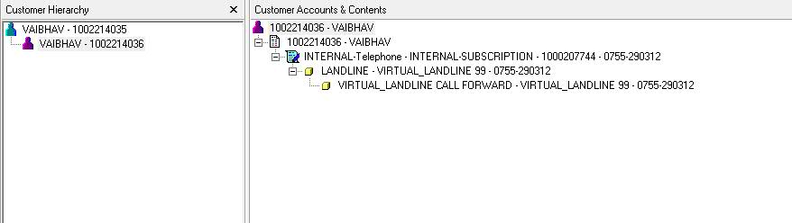

Disconnect Order for Virtual Landline Number
- Open the IBase of a already created number for Virtual Landline and click on Disconnect button on top of the screen and then click on the BSNL Service Order on the pop up window.
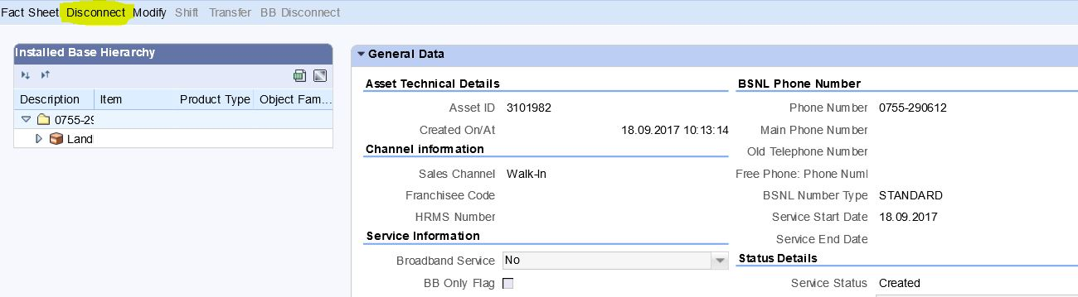

- Select a Disconnection Sub Reason from the drop down menu on the screen.
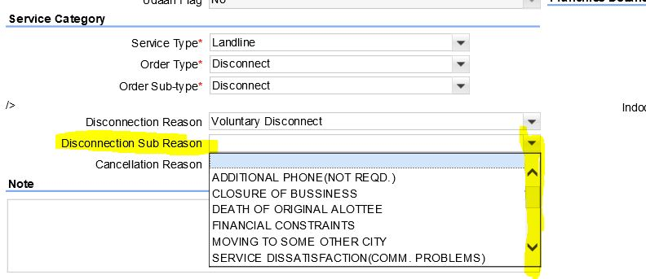
- Save the order a new Disconnect order id will be created,save -> submit → save the order.
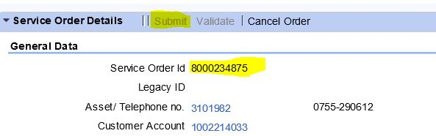

- The order will go to Retention officer and once the order gets failed at retention it will hit clarity and will be completed at the clarity end. Once completed we can check through customer assetes that particular number will come up as inactive.

- We can also cross check the disconnected number at billing end.
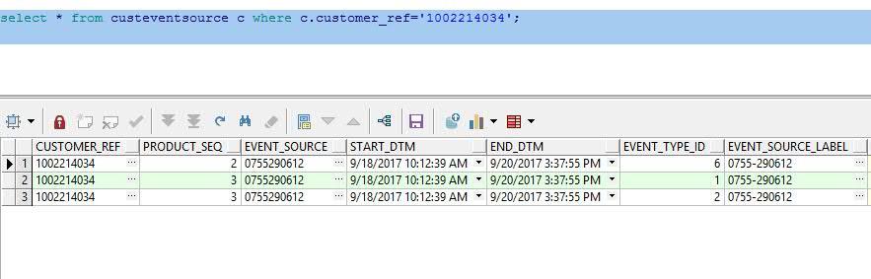

Complaints
There are 2 complaints types :
1. Technical
2. Billing
- Technical Complaints
There is only one sub type for complaints which is service not working. Rest the flow of the complaint is same as normal landline order.
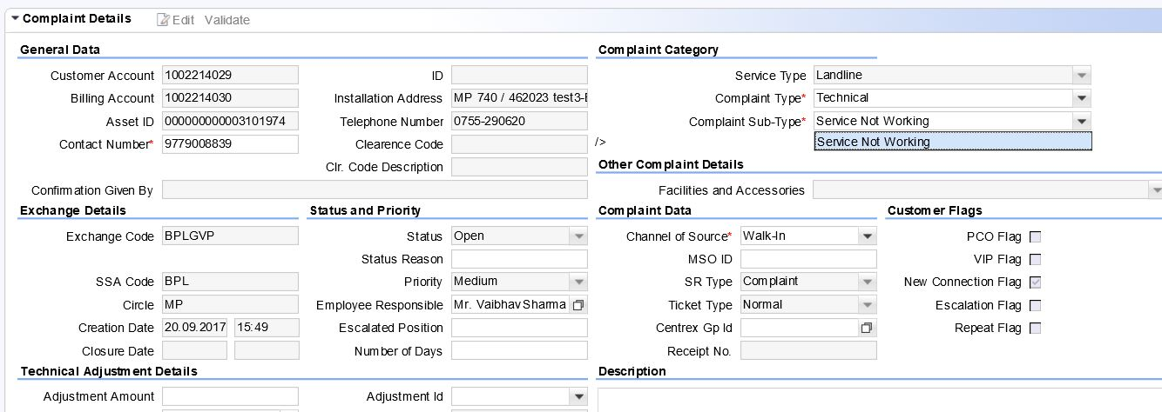

- Billing Complaints
Billing complaints are same as a normal landline order and also follow the same flow.
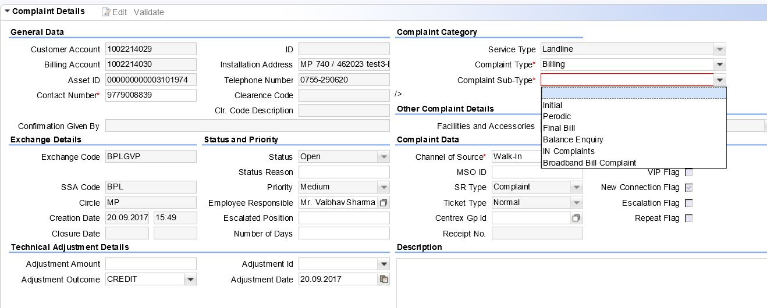

Service Requests
The Service request type are all same as other landline service requests.
- Account Related.
- Billing Related.
- Service Related.
All the change types and sub types will be same as a normal landline order except for billing related service request.
Some requests from billing have been removed for virtual landline order,such as :
- Change of Bill Frequency.
- Change of Bill Statement.
- Central Group Update.
